

Knight creativity

Team members:

Shathan Alhajri 140688

Laith Alhilali 141644

Hamza Alaraimi 142547

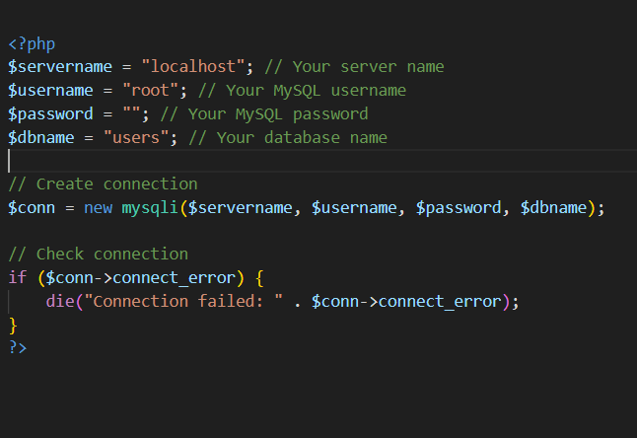db.php page to connect to mysql server

search.php that search for the items in the database connected to

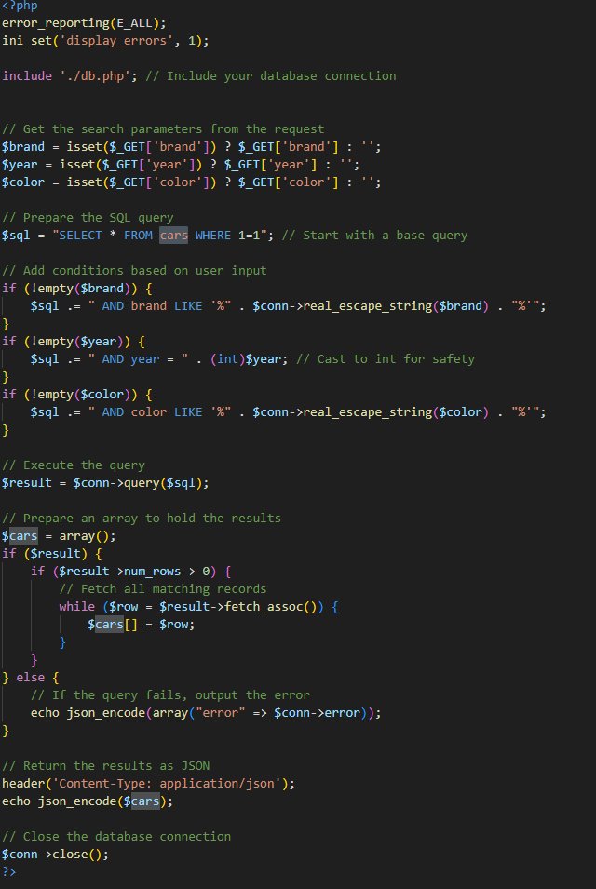search.html

update.php page that update item stored in the database

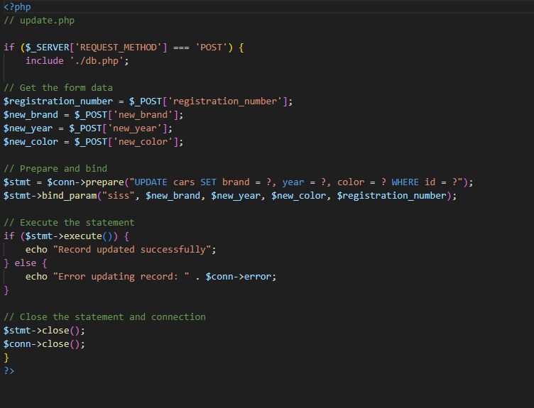

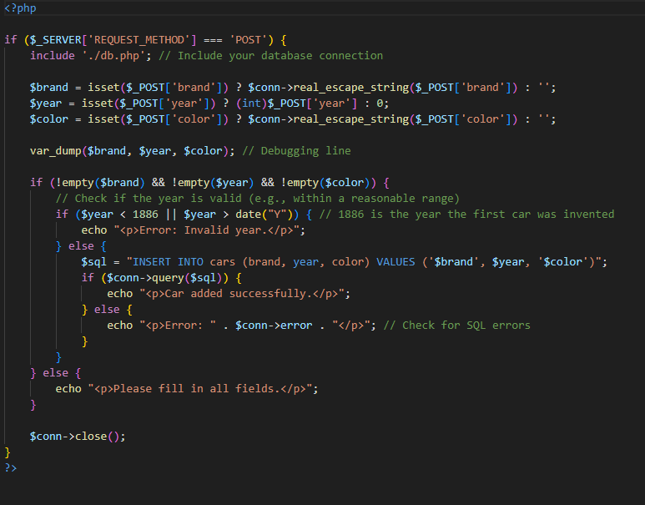Insert.php page that insert an item to the database

calculator.php page that calculate the customer bill and list the items he selected

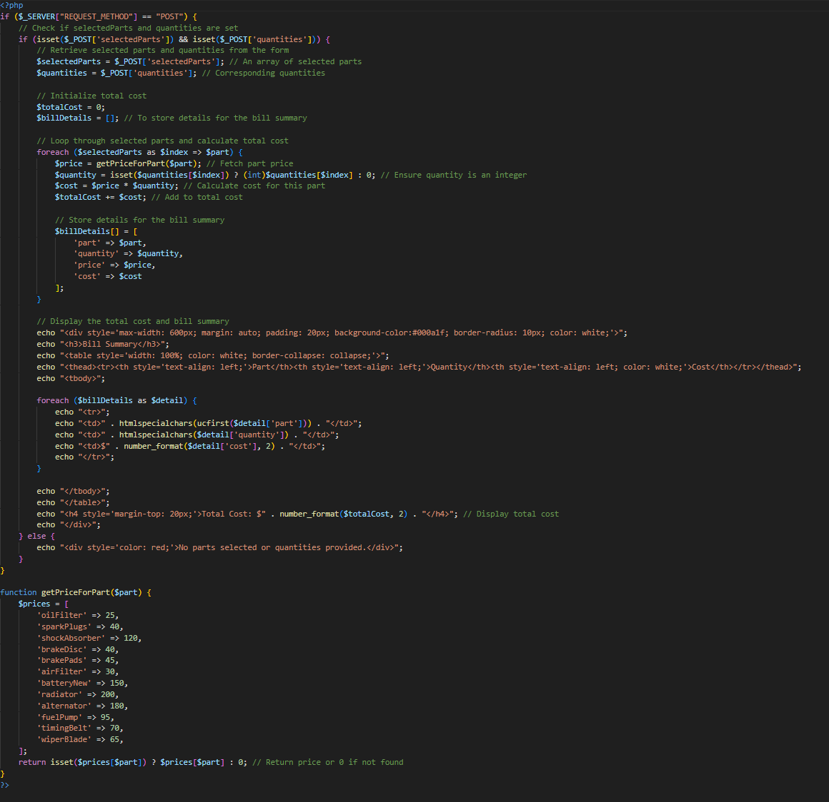

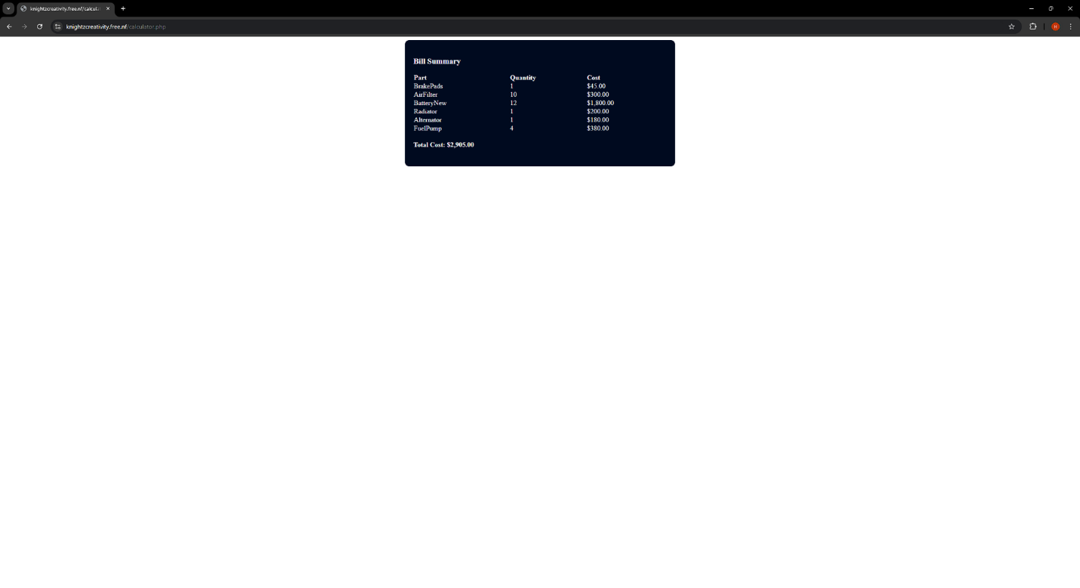

contactas.php send the feedback

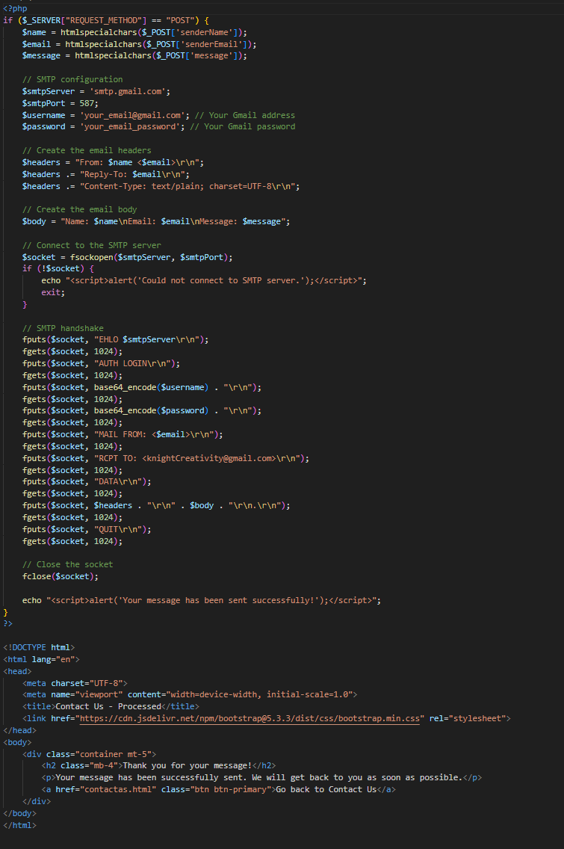

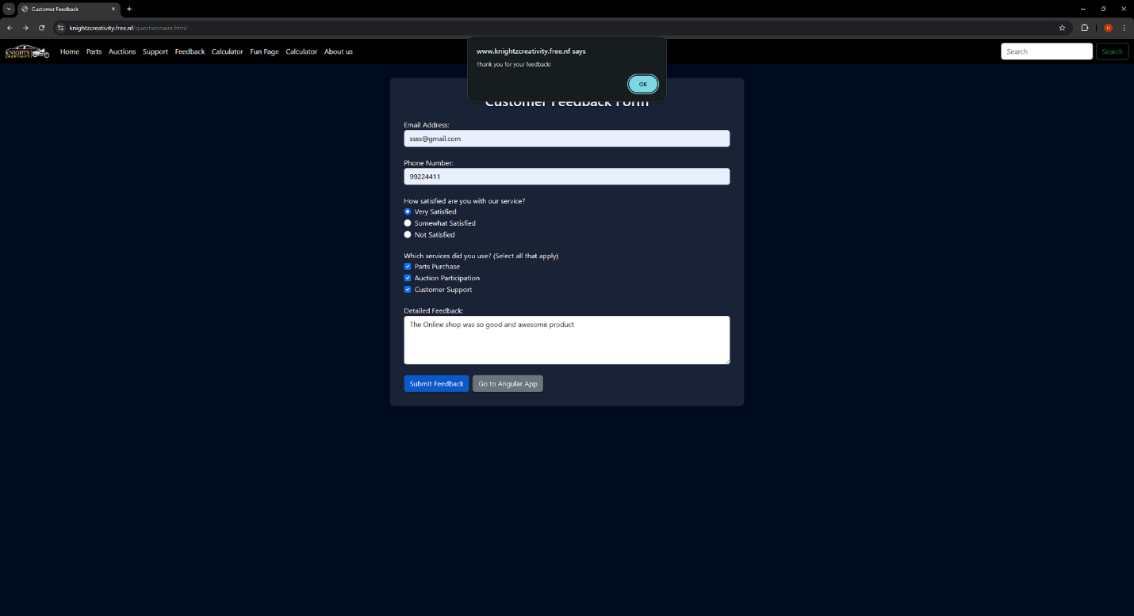

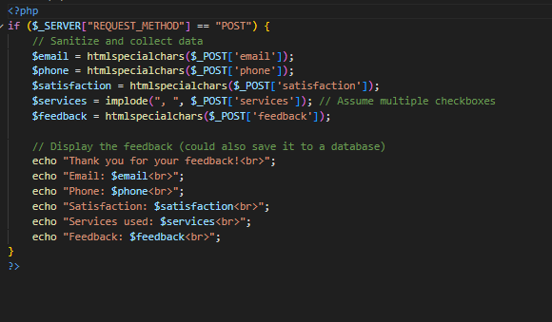questionnaire.php

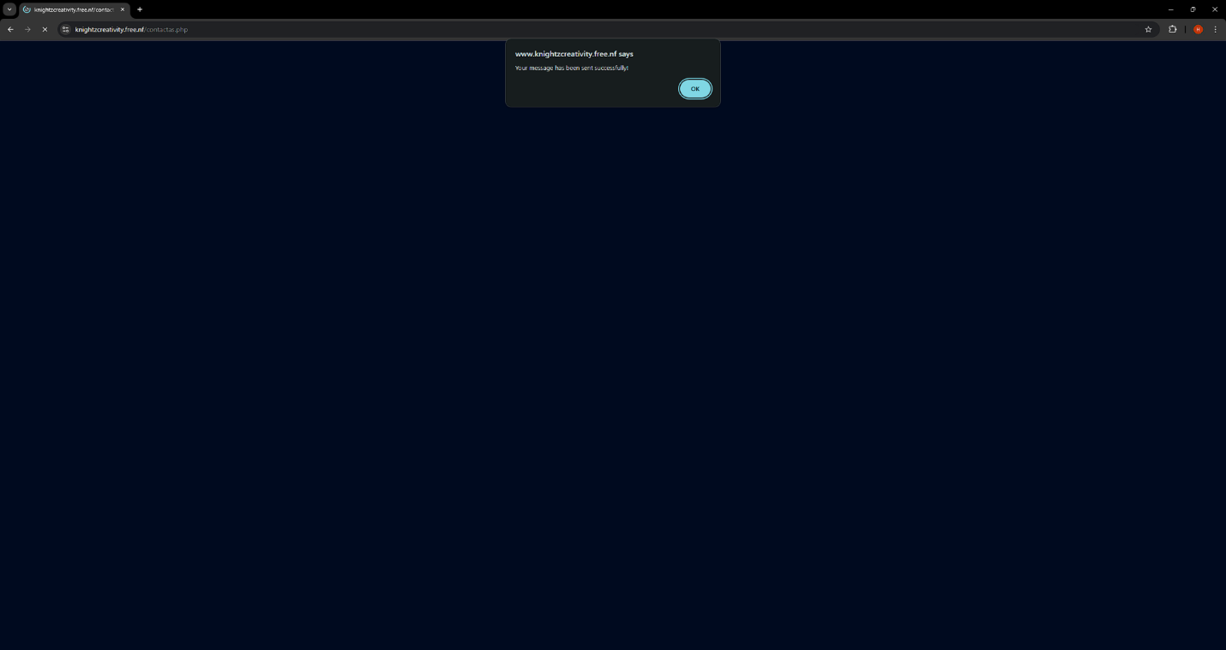

Search.html page

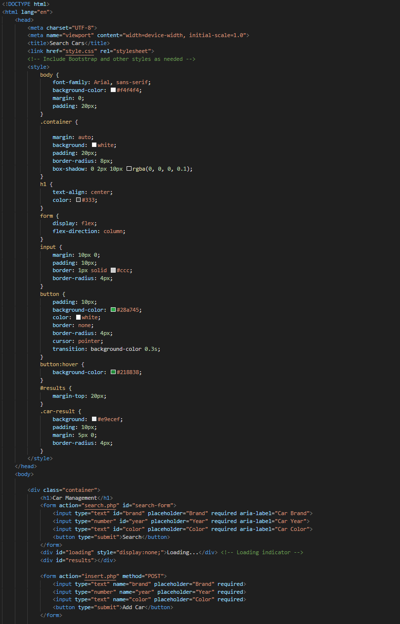

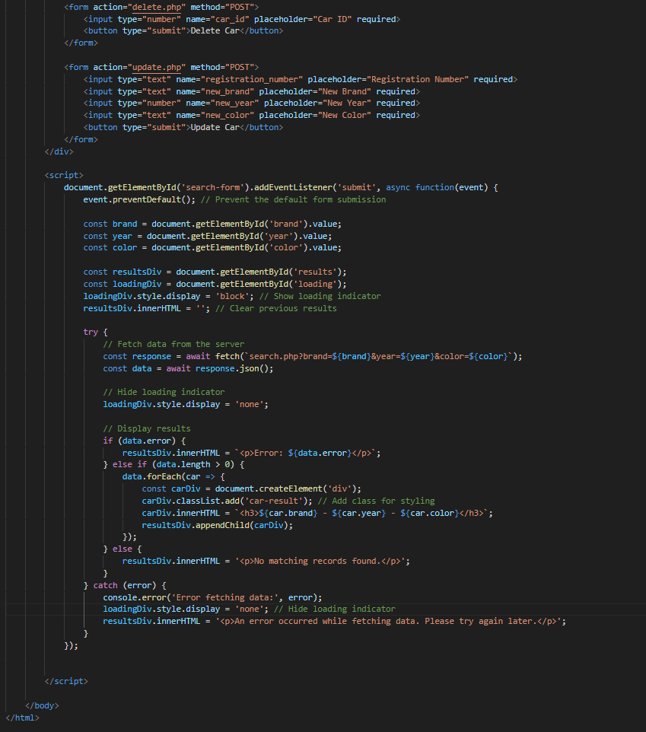

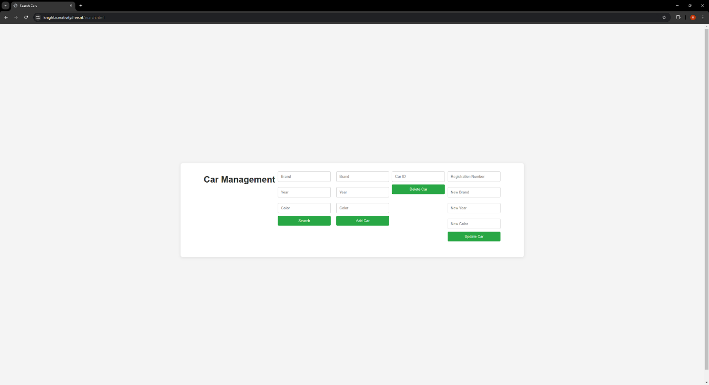

# Contribution table:

|  |  |  |
| --- | --- | --- |
| **Team member** | **Contribution** | **Percentage** |
| Hamza Alaraimi (142547 ) | Database Creation | 20% |
|  | Web Hosting | 10% |
| Shathan Alhajri  (140688) | Search Query and displaying the results | 20% |
|  | SQU queries,  update DB | 20% |
| Laith Alhilali  (141644) | PHP pages to get info from the forms | 20% |
|  | Render the requested info | 10% |

Host link:

<https://www.knightzcreativity.free.nf/index.html>

GitHub link:

<https://github.com/Hamzay443/Hamzay443.git>